Necessary Documents

Step 1: Getting your license translated

- You will need:
- An application form from JAF
- A copy of your driver’s license (both sides)
- *A copy of your alien registration card (both sides)
- Translation fee: 3,000 yen [plus 380 yen for return postage if submitting by mail]

Step 2: Getting a Certificate of Residence
- A Certificate of Residence can be obtained from your City Hall.
- Ask for a 外国人登録原票記載事項証明書
(gaikokujin touroku genpyou kisai jiko shoumeisho)

Step 3: Taking your complete paperwork to the Driver’s License Center

- Take the following things to the Driver’s License Center in Tomigusuku:
- Original license and a photocopy (both sides)
- Alien Registration Card
- Passport and copies of the pages with your name, visa, and date of entry into Japan
- Two standard ID photos
- JAF translation of your license
- Certificate of residence
- About 5,000 yen (this will vary depending on your citizenship, but is generally 2,400 yen)

At the Driver’s License Center

- Take your documents to the Driving License Center on a weekday between 8 am and 12 pm.
- See if there is a Japanese person who is willing to go with you.
- If your documents check out, you will be allowed to make an appointment to take the written exam.

The Written Test

- You can only take the written test on Wednesday mornings.
- There will be 10 true or false questions.
- If you pass, you will be asked to decide whether you will take the test in a manual or automatic vehicle.

- After passing the written test, you can schedule a road test.
- You may have to wait a few weeks for an opening.

Driving School

- An hour lesson will cost about 5,000 yen
- The driving instructor will likely only speak Japanese
- Below is the business card for an English-speaking instructor at Agena Driving School in Uruma:

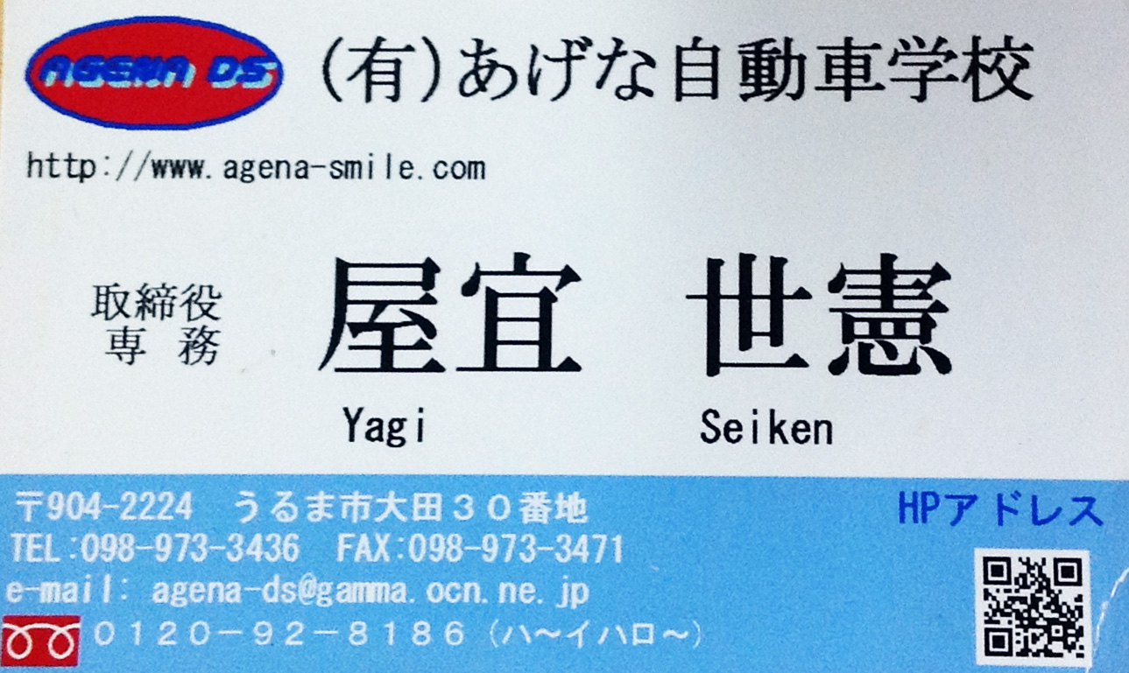

Practical Exam Walkthrough

Before the Practical
- You will wait in a group with your fellow test takers
- A driving instructor will explain the procedure to you (probably in Japanese)
- The driving instructor will call names and announce the test order
- You will head out to the driving course as a group

Before Entering the Vehicle
- Walk around the outside of the car and check to make sure everything is okay.
- You need to:
- Look at the license plate
- Loot at the tires
- Look under the vehicle to make sure there are no animals, people, or pointy objects

Getting Set
- After entering the vehicle, you need to:
- Adjust your seat
- Put your seatbelt on
- Adjust your rearview mirror
- Step on the break
- Put the car into drive and release the handbreak

Heading out
- The car will be parked along a curb and you will likely be heading out towards your right.
- You need to:
- Put your blinker on
- Head-check over your left shoulder
- Check your left mirror, middle mirror, and right mirror
- Head-check over your right shoulder
- Check your middle mirror again
- Pull out

Relax
- The first lap is likely to be a practice lap.

Straightaways
- There will be straightaways where the driving instructor asks you to bring the car up to 30 or 40 km/h.

- You need to:
- Bring the car up to speed as fast as possible
- Keep the car as close to the speed limit as possible

Large Turns
- Coming out of the straightaway, you will approach a large turn.

- As you go into the turn, you need to:
1. Slow down by pumping the break 2 -3 times. This is VERY important. Do it as obviously as possible.

Changing lanes/ Turning at Intersections
- You need to:
- Check your middle rearview mirror
- Blinker
- Check the left or right mirror, depending on which way you are turning
- Check over your left or right shoulder
- Check your middle mirror again
- Change lanes/ Turn

Turning Tips
- Use both hands
- Do not turn by grabbing the inside of the steering wheel
- Do not swerve outwards to the opposite side before making a turn

Crank Turns
- These are really bendy roads with very sharp turns
- You need to:
1. Go VERY SLOWLY (no one is timing you)
- If you run up over the curb:
    - STOP
    - Do mirror and shoulder checks
    - Reverse the vehicle
    - DO NOT CONTINUE DRIVING STRAIGHT OVER THE CURB

At a Stoplight or Stop Sign
- You need to:
- Approach slowly
- Come to a complete stop
- Alternately check right and left
- Continue to check right and left as you move slowly into the intersection
- If there are walls or other obstacles obstructing your view to the left and/or right, lean over your steering wheel as obviously as possible as you check right and left

Finish!
When you reach the end of the course, the instructor will ask you to pull back up to the curb by a numbered sign.
You need to:
- Bring the car as close to the curb as possible. It should be within 30 cm or fewer.
- Bring the car in line with the numbered sign
- If you are too far away from either the curb or the sign, you will lose points

If you fail…
- Don’t worry about it!
- Many people fail on their first attempt.
- You may have to wait two weeks before you are allowed to re-take the exam.

If you pass…
- You will need to back into the driving center to complete your paperwork and pay for your license.
- You will need to take an eye exam and have your photo taken.
- You may have to watch an instructional video before you are allowed to leave.
- You may be asked to pay an additional 1,000 yen contribution to the Okinawa “Safe Driving Fund” (this is totally optional)

Congratulations!
- Don’t forget your new driver seal! You are a beautiful young leaf!

